An Agentic LLM Framework for Smart Agricultural Finance and Farmer-Centric Support

Dr.Sailaja Thota
School of Computer Science and Engineering
REVA University
Bangalore, India
sailaja.thota@reva.edu.in
Bharathan M
School of Computer Science and Engineering
REVA University
Bangalore, India
bharathan.m.blr@gmail.com
Deekshitha Prabhakar
School of Computer Science and Engineering
REVA University
Bangalore, India
deeksdp03@gmail.com
GJ Gautham
School of Computer Science and Engineering
REVA University
Bangalore, India
gjgautham96@gmail.com
Vinay Sai S
School of Computer Science and Engineering
REVA University
Bangalore, India
vinaysai156@gmail.com

Abstract— Smallholder farmers in developing economies often contribute through producing food supplies and supporting livelihoods, and yet, they struggle to have access to basic financial needs or services, with 86.2% of India's farmer population comprising small and marginal farmers unable to access formal credit. Traditional credit systems require formal documentation that rural farmers lack, hence making it difficult for lenders to assess creditworthiness. To add on, agricultural finance systems operate without considering other factors such as weather and the market conditions. This paper proposes an n8n-orchestrated agentic AI framework integrating Large Language Models as intelligent executor nodes within three subsystems, namely, Farmer Profile System (FPS) for financial risk assessment using demographic and farmer data, Environmental Weather System (EWS) for crop-specific meteorological risk, and Market System (MS) for profitability analysis using commodity prices and yield. These subsystems get merged into a Central Insights Engine that utilizes Retrieval-Augmented Generation in order to allow the LLM to rely not only on the trained data but also to pull data from verified government sources. The main purpose of n8n is to allow self-hosted workflow automation with complete control over the data and easy integration with other platforms. The proposed solution allows the system to transform agricultural finance from reactive, document-driven lending to proactive, insight-based advisory, which can identify farmer needs, appropriate timing, and financial services that match those needs.
Keywords— Large Language Models, Agentic AI, Agricultural Finance, n8n Workflow Automation, Retrieval-Augmented Generation, Financial Inclusion, Semantic Reasoning, Credit Risk Assessment, Workflow Orchestration, Weather Intelligence, Market Analysis, Farmer Profiling

Introduction
Agriculture forms the economic backbone for developing countries, supporting livelihoods for more than a billion people around the world, but smallholder farmers in India continue to suffer from reliable financial services despite the productivity that they provide to the economy. This is due to the fact that the formal credit system requires financial documentation in the form of income statements, credit scores, and records of assets, but the rural farmers with seasonal income, undocumented land tenure, and almost no recorded financial history cannot fulfill these requirements. Therefore, banks cannot determine farmer creditworthiness, leading to either rejections of the services or misaligned loan products. About 50% of small and marginal farmers cannot acquire loans from banks or even local moneylenders, and those who get informal credit are often forced to pay high interest rates, which puts them under financial stress. This eventually leads to farmers lacking any source of financial support, and they are forced to postpone buying good seeds, fertilizers, or equipment, making it difficult to invest in practices that help handle climate risks and vulnerability to weather shocks and market volatility that appropriate financial products could mitigate [1] [2].
The traditional loan systems where the farmers borrow money from banks, either in-person or as a paper-based process, do not look at the important factors that affect farmers' crops and businesses, like the weather conditions of the location, the type of irrigation that is being used, or the current market prices. These systems only seem to take the income or credit history of the farmer, which does not seem fair. It can be understood through one such example.
Two farmers with the same income can face extremely different risks, while one might be dealing with drought and unstable crop prices, the other might have reliable irrigation systems and stable markets, and yet both these farmers may be treated the same due to their credit scores. The income from farming can vary depending on factors such as rainfall and market demand, but usually decisions to take a loan do not consider these factors [2] [6]. There are government programs that help farmers with their financial situations, but they are often used less because the eligibility rules of each scheme can be confusing, and also these schemes are not known to the farmers. Due to this, lenders misunderstand the agricultural situation, and the farmers lack receiving the right advice on suitable financial services and opportunities.
Large Language Models (LLMs) have the capability to transform decision-making by understanding the situation in ways that traditional rule-based systems cannot. The traditional systems follow fixed rules like the “if-then-else” rules. These work well for simple tasks, such as the transfer of data, but they struggle when working with complex situations. For example, checking whether rainfall is good or not for a specific area depends on the type of crop, its growth stage, and the condition of the soil in that area. This cannot be handled by rule-based systems but can be dealt with by LLMs because they understand the context through natural language. Yet relying only on LLMs has drawbacks, their knowledge is limited to what they were trained on, they can produce inaccurate results, and they perform worse than specialized machine learning models [10] [11].
This research proposes an n8n-orchestrated agentic AI framework that uses LLMs as semantic reasoning layers with Retrieval-Augmented Generation to ground outputs in verified external knowledge. The architecture of the system breaks agricultural finance into three independent subsystems, namely, Farmer Profile System (FPS), Environmental Weather System (EWS), and Market System (MS), each containing LLM agent nodes performing domain-specific analysis while pre-processed nodes ensure the quality of the input is maintained. These subsystems provide outputs in the form of JSON files, which are then given to a Central Insights Engine where data fusion nodes merge the files of the three subsystems into one record, RAG nodes retrieve applicable government schemes and verified data, and recommender LLM agents generate farmer-comprehensible recommendations for financial products [8] [9] [11]. Using n8n, which is a self-hosted setup, it keeps the data under control and reduces the time delay after being triggered by about 37% when compared to the cloud services. It also reduces the overall cost by 72% and maintains long-term audit records for compliance [9]. By combining LLM with RAG, it allows the system to shift to a more prepared and guided approach by being able to identify which farmer needs support, when to take action, and which financial product is well suited for the situation.

Literature Review
According to [1], the study analyzed data of over 1000 farming households to understand what the factors are that affect loan repayment. It was found that farmers who have better education, higher income, and more assets tend to repay their loans successfully. Whereas farmers who take loans from informal sources like moneylenders tend to fail in repaying their loans on time, which increases a risk of 40%. The study also showed that formal credit systems are more stable than informal borrowing. The study does not consider how a farmer’s income changes throughout the year or how weather and market prices affect crops and earnings, respectively. It also did not consider how a farmer’s credit needs and ability to repay vary during the different stages of the farming cycle.
As mentioned in [2], a survey was taken of 500 farming enterprises and used logistic regression to predict which farmers could successfully repay loans. The accuracy achieved was 93.5%, and the ‘Working Capital Ratio’ was one of the most important factors in predicting repayment. Discriminant analysis was also used in order to identify the factors that cause risks to occur. The study has some limitations as it focuses only on one state, relies on financial data that is given by the farmers directly, and analyzes static data. These issues made it difficult to understand how farmers' income and market conditions change across seasons.
In [3], researchers used BiLSTM along with TimeSHAP to predict different climate risks like flood, frost, hail, and heatwaves. The model performed well and could predict as well as explain when and why those risks occurred. But it had some problems, like the model needing a large amount of past data, requiring powerful computers with GPUs to run, and working well only in specific areas that it was trained on. Due to such conditions, it is difficult to use in rural areas where the data is limited and resources are not easily accessible.
Similarly, [4] has shown that deep learning models can accurately predict different agriculture-related risks and also explain why they occur and what causes this occurrence. This makes the model useful for understanding and planning around these risks. But the model has drawbacks, as it requires detailed data that is collected for over 10 years, needs powerful computers to run, and should be retrained for every new region, which can be expensive and time-consuming. These requirements make it difficult to actually use the system in real-world situations.
According to [5], the study uses a combination of K-Nearest Neighbors and LSTM models to predict floods in the Imphal Valley with an accuracy of 91% while also providing a 5-day early warning so that the farmers can take the necessary actions. Even though it worked well at predicting how the floods occurred and spread over time and across places, it could not handle when the water levels were higher than what was mentioned in the training data. It is also designed specifically for one location, which means it would not work well for other areas unless it were adjusted.

As discussed in [6], it uses Decision Tree models on past market prices in order to decide the best time for farmers to harvest their crops. The model’s performance was good with almost perfect accuracy, and it helped farmers increase their revenue by 18% to 25% when they followed the specific timing. The model mentioned that the study depends on the past data and cannot handle unexpected situations like any economic crises or changes in the demand and availability of resources. These unexpected events can reduce the model’s accuracy.
Based on the study in [7], there are three machine learning models used to predict the crop prices, which are XGBoost, Random Forest, and Decision Tree. These perform very well because they can understand the relation between important factors like the quality of soil, the irrigation methods, and the usage of fertilizers. But this paper focused on testing these models only for one state, which can cause incorrect results for any other location. The data used was also generated synthetically, which may cause inaccuracies when testing in real-world scenarios.
As per the context of [8], when multiple tasks are executed at the same time, the performance and speed of the system increase, and it can handle 35% to 45% more work than running tasks in a step-by-step manner, even though it is simple and easy to maintain, the speed is reduced and it does not perform well. But during parallel execution, the nature of the system becomes more complex, which makes it difficult to handle errors. To handle such errors and inaccuracies’, the system uses some mechanisms like retrying tasks that have failed, having backup processes, and checking if the output is valid or not.
In [9], the study talks about n8n, which is a self-hosted platform that reduces the response time by 37% and cost of operations by 72% when it is compared with cloud-based platforms. This self-hosted platform ensures stability and stores the sensitive data locally, which meets India’s data localization rules and regulations. This requires skilled people in order to manage the system. The advantages of n8n are one of the reasons it was chosen to manage the workflow of the system.
According to [10], the research compares models from 396,000 loans used as the data and it was found that for predicting the credit risk, the accuracy of LightGBM is more accurate than the GPT-4 model, even though both these models seem to identify similar factors affecting the risk. It also mentions that since LLMs explain in natural language, the farmers find it easy to understand but also, these explanations can differ when using SHAP. This can cause the output to be inaccurate, and to solve that, a hybrid approach is taken where LLMs are used for explaining the results, RAG is used for making sure the data is accurate and reliable, and traditional models are used for predictions in a precise manner.
The study shown in [11] tested five different LLMs and it was found that the LLM that was using RAG had a higher accuracy than the other LLMs, but the speed of the system was reduced. It also showed that the performance of the LLM with RAG depends on how it is set up. Factors such as how the data is split, how the data is converted into numerical forms, and how the system decides which data is relevant.
Finally, in [12], it reviewed the use of vision models and vision-language models in agriculture. These models are very good at identifying crop diseases, including the rare ones that they have not seen before. However, they need a lot of computing power and are very large in size and run slowly. This makes it difficult to use in rural areas where internet speed and computing resources are limited.
The given table, Table 1, shows a frequent issue, which states that most solutions work well in isolation but fail to come together into a complete system for agricultural finance decision-making. Studies on loan repayment and default, such as [1] and [2], rely mainly on static financial indicators and one-time surveys, ignoring seasonal income changes for farmers, weather risks, and market conditions that directly affect a farmer’s ability to repay. Weather-based models as mentioned in [3], [4], and [5] can predict hazards accurately, but they do not consider how the farmer’s income, expenses, and crop prices are affected by the weather conditions. So, farmers get information regarding the weather but not how it would affect making financial decisions. In the same manner, the market and cost-predicting models mentioned in [6] and [7] show high accuracy for specific situations, but they do not work well when any unexpected event occurs like when the price drops or rises suddenly. Also, only the market prices are taken into consideration and not the farming and environmental factors, which are also very important. The studies about workflow automation in [8] and [9] show that the systems work well in an efficient manner, but they can create issues on the privacy of the data and access control if cloud services are utilized. The research done on LLMs and RAG in [10] and [11] shows that LLMs are good at generating outputs with proper reasoning, but they have lower accuracy when compared to specific machine learning models. The vision-based models described in [12] are difficult to use in rural areas because they require high power for computations, and certain resources may not be available in these areas.
Reference Paper Number | Focus Area | Limitations / Gaps Identified
[1], [2] | Loan repayment & default prediction | Ignore seasonal income variability, weather risks, and market fluctuations affecting repayment capacity
[3], [4], [5] | Weather hazard prediction | No link between weather predictions and financial outcomes
[6], [7] | Market & cost prediction | Poor adaptability to unexpected events and no integration with finance or climate interactions
[8], [9] | Workflow automation & cloud infrastructure | Data sovereignty concerns, external control over sensitive agricultural and financial data
[10], [11] | Large Language Models (LLMs) & Retrieval-Augmented Generation (RAG) | Reduced numerical accuracy vs. specialized ML and, requires factual grounding
[12] | Vision-based agricultural AI systems | High computational requirements, impractical for rural, low-resource environments
Table 1: The gaps identified from the existing reference papers
The proposed solution of using the n8n agentic AI framework covers the mentioned research gaps by bringing together the best parts of various approaches. It uses LLMs to understand the farmer’s situation and explain the results in natural language, making it easy for the banks to understand and convey to the farmers. It also uses RAG in the LLM to make sure that the information being used is from a verified source so that errors and hallucinations can be reduced. The use of n8n allows the data to be stored locally rather than being sent to external platforms. By combining the financial data, the weather conditions, and the market information into one workflow, the system replaces the unclear advice with timely and clear recommendations. This allows agricultural finance to move from reacting to problems to proactively supporting farmers, thus anticipating their needs, suggesting the right financial products at the right time, and explaining decisions in simple and easy-to-understand language.

Methodology
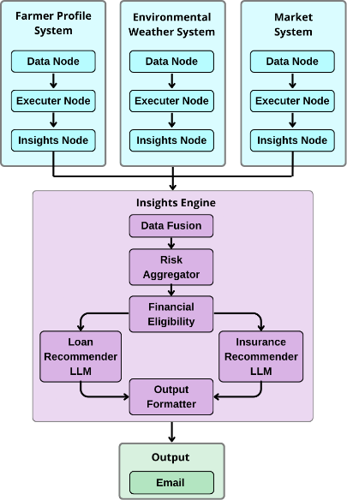
Fig. 1. The architectural design of the proposed system

System Architecture
As illustrated in Fig. 1, the proposed system consists of three subsystems: Farmer Profile System (FPS), Environmental Weather System (EWS), and Market System (MS). These systems provide results, which are then fed to a Central Insights Engine. Together, it converts the data from the subsystems into explainable financial and risk recommendations using LLM-based reasoning.

Farmer Profile System (FPS)
In the Farmer Profile System, the methodology begins by integrating three datasets: individual farmer form data, district-level labour data, and district-level crop irrigation data [13] [14]. Farmer inputs such as state, district, crop, land acres, annual income, existing loans are normalized by lowercasing and trimming text fields and validating numeric fields. District labour data is processed and put into categories like Low, Medium or High labour availability in order to specify the work access. Crop-wise irrigation statistics are used to calculate an irrigation ratio for each district and crop combination and is then categorized into irrigation support levels such as High, Medium, or Low. The irrigation ratio is calculated as
Irrigation Ratio = $\frac{Total Irrigated Area }{Total Irrigated Area + Total Unirrigated Area}$
FPS also identifies financial indicators like the debt-to-income ratio and the financial risk score. These are calculated as
Debt-to-income = $\frac{Existing Loans }{Annual Income}$
Financial Risk = Debt-to-income × 100

Environmental Weather System (EWS)
The Environmental Weather System uses meteorological data to provide a weather risk summary. It utilizes three fields: daily rainfall per district, average monthly rainfall and normal temperature values [15]. The daily rainfall values show both the actual as well as the normal (expected) rainfall values for a specific date and location. The system then computes a rainfall deviation percentage which is calculated using the formula,
Rainfall Deviation Percentage =
$\frac{Annual Rainfall-Normal Rainfall}{Normal Rainfall} ×100$
This formal helps in categorising the rainfall status into divisions such as “Severe Deficit”, “Deficit”, “Excess” or “Normal” based on the pre-defined threshold values. The EWS system also utilizes rolling indicators such as the seven-day cumulative rainfall as well as the consecutive dry days where the actual rainfall value is less than the threshold value. These elements are put together to form a small structured JSON file for each district and day. This file is given to the LLM that analyses the weather data based on the specific crops, checks if the weather conditions are suitable, calculates the weather risk score, indicates for any possible flood or drought situations, and generates a short recommendation.

Market System (MS)
The Market System acts as a decision-making layer by utilizing three types of data: the yield benchmark, the market price benchmark, and the input cost datasets [16] [17] [18]. The yield benchmark dataset consists of details regarding the expected yield per acre, the location, and the crop. It shows how many kilograms a farmer can expect to harvest one acre of a specific type of crop in a specific location. The market price benchmark dataset provides the minimum, maximum, and average modal prices for each crop and market on a daily basis. The price range is calculated in order to represent the short-term price fluctuations,
$$Price Range = Maximum Price - Minimum Price$$
This is later aggregated by using each normalized crop name in order to avoid a Cartesian explosion while merging. It is aggregated by calculating the market sample size, average modal price, and average price range.
Market Sample Size = Number of Markets the specific crop is present in
Average Modal Price = $\frac{ΣAverage Modal Price across Markets}{Market Sample Size}$
Average Price Range = $\frac{ΣPrice range across Markets}{Market Sample Size}$
The input cost dataset aggregates the total cultivated area and total fertilizer applied, thus providing the system to compute the fertilizer per acre.
Fertilizer Per Acre = $\frac{Total Fertilizer Applied}{Total Cultivated Area}$
This is used to classify the intensity of the input cost into labels such as "None," "Low," "Medium," and “High” based on certain threshold values, allowing the LLM to understand the financial strains in a quantitative manner.
The three datasets are merged to provide a final market feature dataset that consists of expected yield per acre, average modal price, average price range, market sample size, average input cost per acre, and input cost intensity. All these factors are used by the LLM to compute the market risk score, profitability score, and expected revenue, which is derived using,
Expected Revenue = Expected Yield × Average Modal Price.
The market risk score uses price range and market sample size to determine the market risk, which is normalized on a scale of 0 to 100. The profitability score uses the expected revenue, input cost intensity, and market risk to classify the profits as “Low,” “Medium,” or "High."

Central Insights Engine and Recommendation Layer
The three subsystems have each generated output in the form of structured JSON files, where the Farmer Profile System provides the financial risk, capacity index, and size category. The Environmental Weather System provides the weather risk, and the Market System provides market risks and profitability. The three outputs from the subsystems are merged into one dataset in the Central Insights Engine that computes the average risk from the combination of the subsystem risks. The Central Insights Engine loads the JSON file that consists of the financial necessities and government schemes, which then get filtered out when not satisfied by the required conditions such as crop, region, land size, and capacity. Retrieval Augmented Generation is used to get the most relevant rule as well as the eligibility criteria into the Loan Recommender and the Insurance Recommender. These agents generate the recommended financial need and products in the form of a plain language that would vary for each farmer. The final output is provided as a notification alert to the banks, who will let the farmers know the information of the financial needs.

Results
The implemented workflow generates a personalized recommendation for the farmers by integrating multiple data sources into a single processing pipeline. Based on the integrated data of the farmer’s profile, environmental conditions, and market prices, the framework evaluates three types of risks- financial, environmental, and market risks. Financial risk is calculated using farmer’s financial condition, land size and irrigation support. Environmental risk is evaluated using rainfall, temperature conditions and extreme weather situations. Market risk is estimated using crop yield, crop prices and agricultural input costs. The risks are aggregated into one risk profile that consists of both structural farm characteristics and dynamic external conditions.
Using the generated risk profile, the system produced a personalized recommendation output that is designed for delivery through an email, which is sent to the bank. Each recommendation consists of a summary of the farmer’s current risk level, an estimate of the potential profitability of the selected crop, and the actions that can be advised for the farmers. The system also evaluates the eligibility conditions to recommend the appropriate financial needs, as each recommendation mentions a small explanation that links with the farmer’s financial condition, environmental exposures, and the market dynamics.

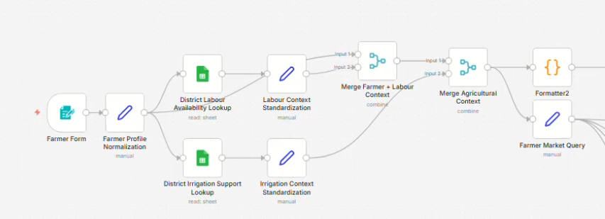
Fig. 2. Farmer Profile System implementation in n8n

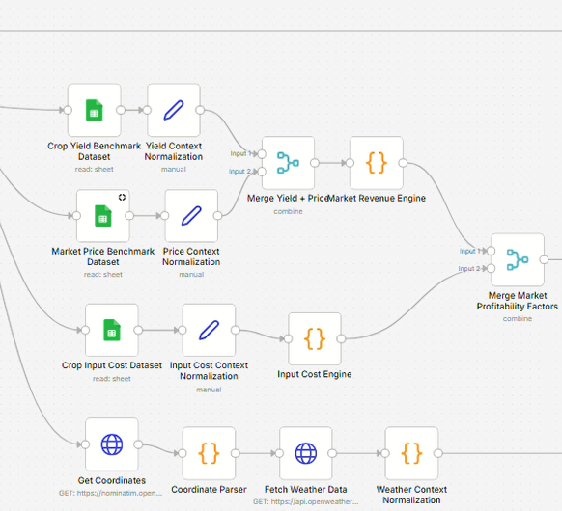
Fig. 3. Market System and Environmental Weather System implementation in n8n
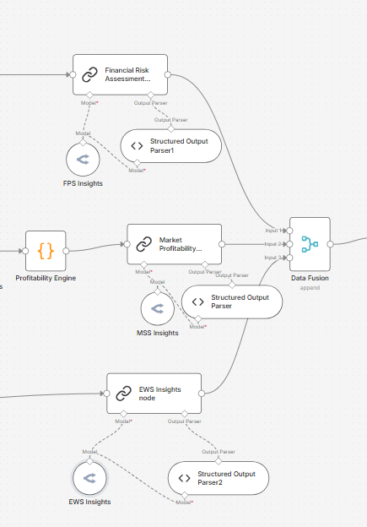
Fig. 4. Combining the 3 subsystems' insights into the Data Fusion Node

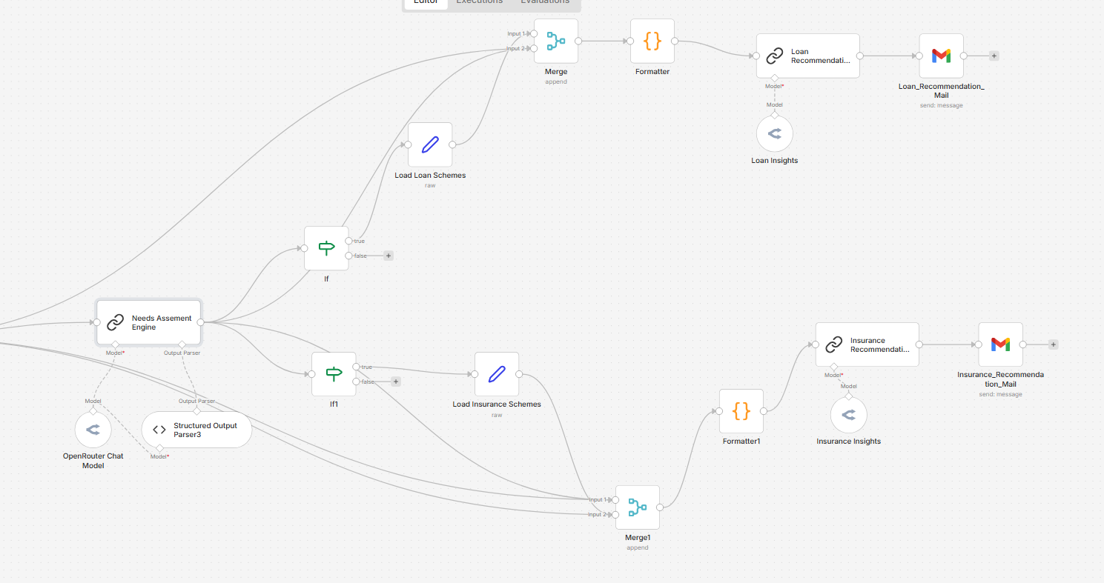
Fig. 5. Central Insights Engine implementation in n8n
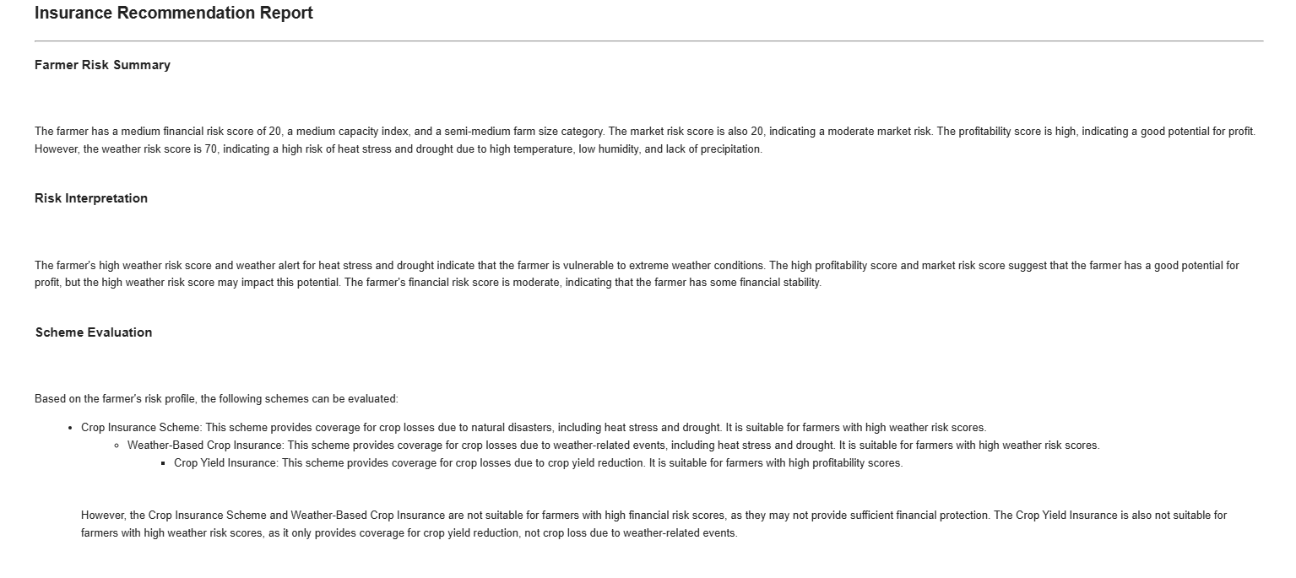
Fig. 6. Email notification that will be sent to the bank

As depicted in Fig. 2, Fig. 3 and Fig. 4 the “Farmer Market Query” trigger activates parallel data ingestion from the three benchmark datasets which are the crop yield benchmarks, market price benchmarks and crop input cost datasets. Each dataset undergoes normalization to ensure the data is structured and easy to process further. The yield data is passed into an LLM to generate FPS insights in JSON format. The yield and price flows are merged and processed through a Revenue Engine module, whereas the input cost dataset is analysed separately using an Input Cost Engine module. The outputs of these components are further combined in the “Merge Market Profitability Factors” node and evaluated by the Profitability Engine, which estimates the crop profitability. The resulting output is then passed to an LLM node that generates the MSS insights in JSON format. The weather data is passed through an LLM node which provides the EWS insights in the form of a JSON file. These three insights are further combined in the data fusion node where it passed through an LLM to recommend the financial needs for the farmer and generates the personalized recommendation as shown in Fig. 5. This is then sent as an email to the banks, who will further inform the farmers as shown in Fig. 6.

Challenges
The implementation of the system brings along certain difficulties in terms of the data, how the LLM behaves, and how different parts of the workflow orchestrate themselves. One of the major issues was the data availability and integration. The system utilizes various sources of data, such as the weather data, the crop prices, and the survey regarding the farming costs. These datasets were not in an organized manner, they had different field names and different formats and consisted of missing or incomplete data, which requires more effort in cleaning, normalization, and matching the fields before being processed further by the workflows and execution. For future improvement, a standardized data structure or schema layer that automatically detects data formats can be utilized and it uses validation checks to identify and reject the incorrect data before it can be further processed in the system, making it more efficient.
Another problem that is prevalent is the large dataset processing inside n8n. As certain agricultural datasets consist of too many records of data, it becomes difficult to process in n8n since it uses more memory and produces large intermediate outputs that are difficult to handle and debug. In order to manage this, summarization of the data and restructuration of the data was done before adding it into the workflow.
The framework uses LLM agents to analyse financial, weather, and market-based information, and hence, it is very crucial to make sure that the prompts are written correctly. The properly designed prompts allow the model to generate the structured JSON outputs and help in avoiding hallucination of data. To achieve this, a lot of prompt testing and refining were done. This can be improved by adding example cases in evaluation tests for the model’s output.
One more difficulty was trying to match the location data. The agricultural datasets that are available are only at larger levels, such as national, state, or district, whereas farmers provide specific locations like villages. Due to this, the system had to map village-level inputs that the farmer provides to the closest available level, which would be the district in this case. Even though this works, there are some inaccuracies that are brought in. Hence, the results can be improved by using a more detailed geospatial dataset in order to increase reliability.
Another challenge is how the data is prepared for the model using RAG. The system splits large documents, texts, and tables into smaller pieces so that the model can get the required information and process them, but this chunking process can be difficult to do, as these chunks require enough context to understand the situation, but, at the same time, they should not have any unnecessary information. So, if this process of splitting is not done properly, the system has a chance of sending too much irrelevant data to the LLM, which can reduce the performance of the system and increase the inaccuracies. This can be improved by using different, rather smarter ways to split data based on the type of document, tables, or lists.
One of the final difficulties was that the system faced issues while dealing with large data transformations in the n8n platform. As the workflows become more complex, tasks such as processing JSON files or preparing API requests can slow down the system and, hence, make it difficult to debug. This can be tackled by transferring the heavy data processing into a separate data storage or database. This way n8n will not focus on performing large computations but will instead focus on managing the workflows.
While the system’s workflow is functioning, it still requires certain number of improvements to be made in order to be used on a large-scale and in real-world scenarios. It needs better checking techniques for the quality of the data, more efficient methods for processing the data, better way of handling the results generated from the LLMs, and also proper monitoring of the workflow of the system. These modifications or improvements can make the system more stable, reliable and scalable.

Conclusions
The paper explains a system that combines the Farmer Profile System, the Environmental Weather System, and the Market System using n8n, which brings together all the required information regarding the farmer data, weather, and market conditions. All this data is put together into one pipeline, which consists of LLMs that help in analyzing the financial, environmental, and market-based risks. These risks are combined together to form a single risk profile that is specifically meant for each farmer.
The system also uses the risk profile in order to generate personalized recommendations for the farmer, which are sent as an email notification to the bank so that they can store the results for future scenarios as well as inform the farmers of the financial needs that are best suited to them. It also suggests financial options such as loans or insurance while making sure that these match the requirements of the farmer’s situation. The system uses RAG to make sure that the model is functional only with data that is verified and is from a reliable source.
The solution shows how the system proposed and designed here helps in creating a smarter approach in the field of agricultural finances. It helps farmers in making better decisions and also allows banks or financial institutions to check the probable risks of the situation in a much better and easy manner with a higher accuracy than the existing systems.

References
- Chakraborty, Tanika, and Aarti Gupta. Loan repayment behaviour of farmers: Analysing Indian households. Indian Institute of Management Calcutta, 2023.
- Karmur, Alpa, et al. "Determinants of loan default and repayment capacity among farmers in Gujarat: an application of discriminant function analysis." Int J Stat Appl Math 10 (2025): 31-38.
- Sekyere, Andrew Osei Owusu. "Modeling Thunderstorms Using Machine Learning for WA." (2024).
- Zheng, Boyuan, and Victor W. Chu. "Multi-Hazard Early Warning Systems for Agriculture with Featural-Temporal Explanations." arXiv preprint arXiv:2507.22962 (2025).
- Singh, Leishangthem Sashikumar, et al. "An Integrated Machine Learning and Deep Learning Framework for River-Based Flood Early Warning System." IDRiM Journal 15.1 (2025): 77-102.
- Sable, Nilesh P., et al. "Optimizing agricultural yield: a predictive model for profitable crop harvesting based on market dynamics." Frontiers in Computer Science 7 (2025): 1567333.
- Bari, Poonam, and Lata Ragha. "Machine learning-based extrapolation of crop cultivation cost." Inteligencia Artificial: Revista Iberoamericana de Inteligencia Artificial 27.74 (2024).
- Niu, Boye, et al. "Flow: Modularized agentic workflow automation." arXiv preprint arXiv:2501.07834 (2025).
- Pawar, M. "A practical evaluation of self-hosted N8N for secure and scalable workflow automation." International Journal of Scientific Research in Engineering and Management 9.6 (2025): 1-9.
- AlMarri, Saeed, et al. "Interpreting LLMs as Credit Risk Classifiers: Do Their Feature Explanations Align with Classical ML?." arXiv preprint arXiv:2510.25701 (2025).
- Dayarathne, Ranul, Uvini Ranaweera, and Upeksha Ganegoda. "Comparing the performance of llms in rag-based question-answering: A case study in computer science literature." International Conference on Artificial Intelligence in Education Technology. Singapore: Springer Nature Singapore, 2024.
- Zhu, Hongyan, et al. "Harnessing large vision and language models in agriculture: A review." arXiv preprint arXiv:2407.19679 (2024).
- https://indiadataportal.com/p/census-pca-demography/r/moha-census_pca_demography-dt-dc-abc
- https://indiadataportal.com/p/agricultural-census-crop/r/moafw-agcensus_crop-dt-qq-tos
- https://openweathermap.org/api
- https://indiadataportal.com/p/area-production-yield-apy/r/moafw-area_production_yield-dt-sn-qzf
- https://www.data.gov.in/resource/current-daily-price-various-commodities-various-markets-mandi
- https://indiadataportal.com/p/input-survey/r/moafw-input_survey_crop-dt-qq-aaa

